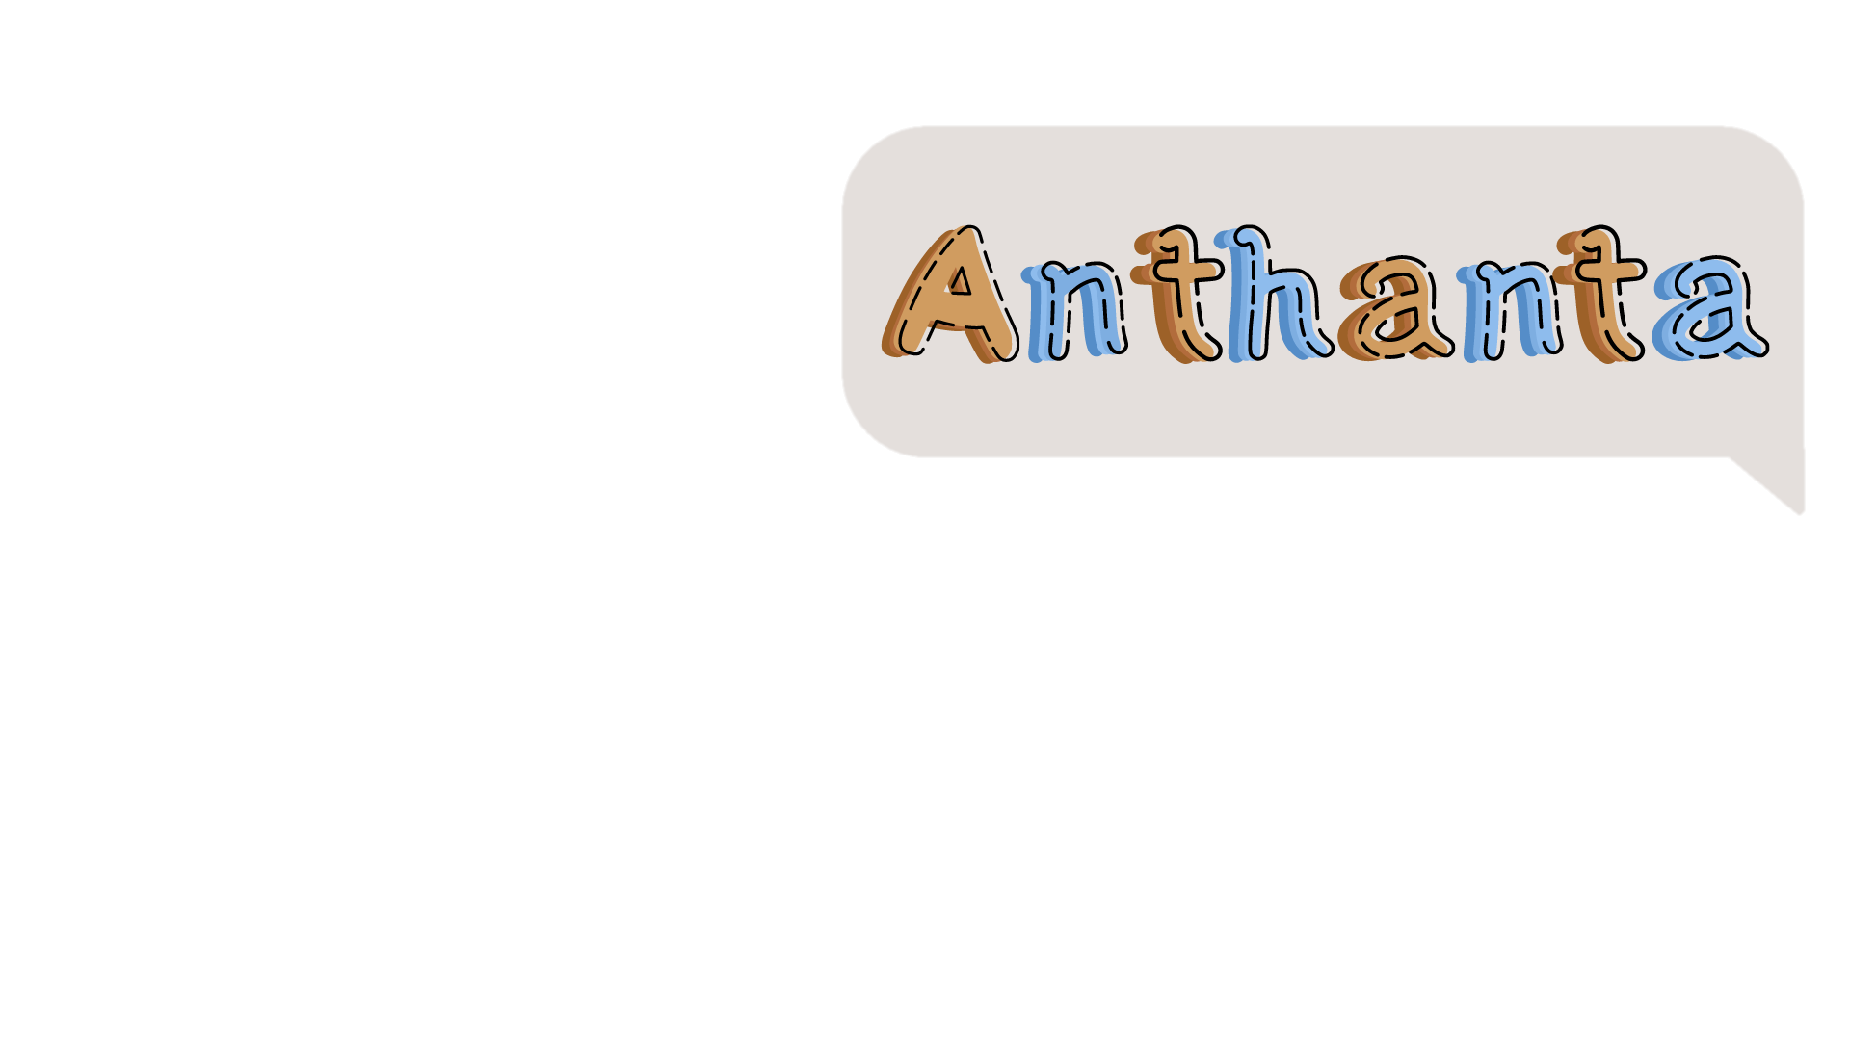

Project documentation



Table of Contents

Resume 2

Team 2

Idea 3

Used programs 3

How difficult it was? 3

# Resume

Anthanta is an engaging and educational mobile application developed by our team The app is designed to facilitate the learning and understanding of world history, specifically focusing on the period around the year 1900, encompassing global events as well as Bulgarian history.

# Team

* Filipa Popova  
  [FHPopova21@codingburgas.bg](mailto:FHPopova21@codingburgas.bg)
* Dobril Peev  
  [DDPeev21@codingburgas.bg](mailto:DDPeev21@codingburgas.bg)
* Kristina Zheleva  
  [KMZheleva21@codingburgas.bg](mailto:KMZheleva21@codingburgas.bg)
* Stefan Ivanov  
  [SBIvanov22@codingburgas.bg](mailto:SBIvanov22@codingburgas.bg)
* Lachezar Gospodinov  
  [LGGospodinov22@codingburgas.bg](mailto:LGGospodinov22@codingburgas.bg)
* Stiliyan Gochev  
  [SNGochev22@codingburgas.bg](mailto:SNGochev22@codingburgas.bg)

# Idea

Our application aims to support the development of knowledge in the field of History, through short and easy questions, following the world and Bulgarian past.

# Used programs



# How difficult it was?

|  |
| --- |
| Difficulties: |
| 1/10 – not difficult \ 10/10 – very difficult |

|  |  |
| --- | --- |
| Communication | 2/10 |
| Code | 5/10 |
| Teamwork | 2/10 |
| Role distribution | 4/10 |